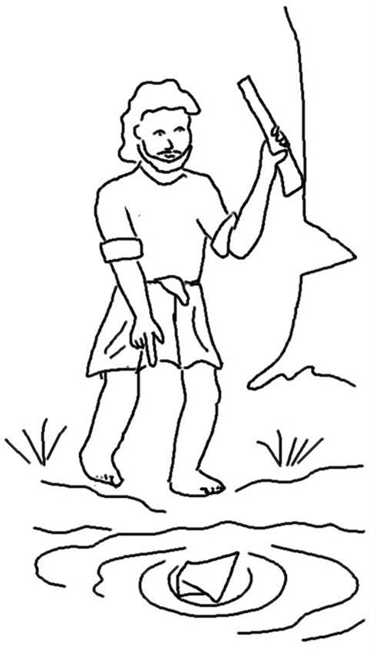
With man this is impossible, but with God all things are possible. Matthew19:26 _{NIV}

